I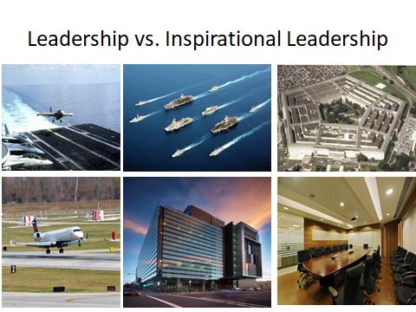
Lot of leadership presentations. Broad perspective: 50 year career, Fortune 500 and entrepreneurial start up, military, government, non-profit and political arena. 5 commanding officer tours, presidential and governor appointments, board member. VP/partner. Responsible for 100,000 people, $450b portfolio. Studied, read, learned from respected leaders, educational institutions. Worked with Wall Street, Pension funds, Insurance Companies, Private Equity.

